|  |  |
| --- | --- |
| NMID | DC1D9FB682DE605B5E14ADA9DB49001C |
| DATE | 30-10-2023 |
| PROJECT TITLE | How to Create a Brand Promo Video Using Canva |

**1.social media advertisement poster on canva**

[**https://www.canva.com/design/DAFytgA6Icg/J0fmOWDCjP9lALbfTWzwXA/edit?utm_content=DAFytgA6Icg&utm_campaign=designshare&utm_medium=link2&utm_source=sharebutton**](https://www.canva.com/design/DAFytgA6Icg/J0fmOWDCjP9lALbfTWzwXA/edit?utm_content=DAFytgA6Icg&utm_campaign=designshare&utm_medium=link2&utm_source=sharebutton)

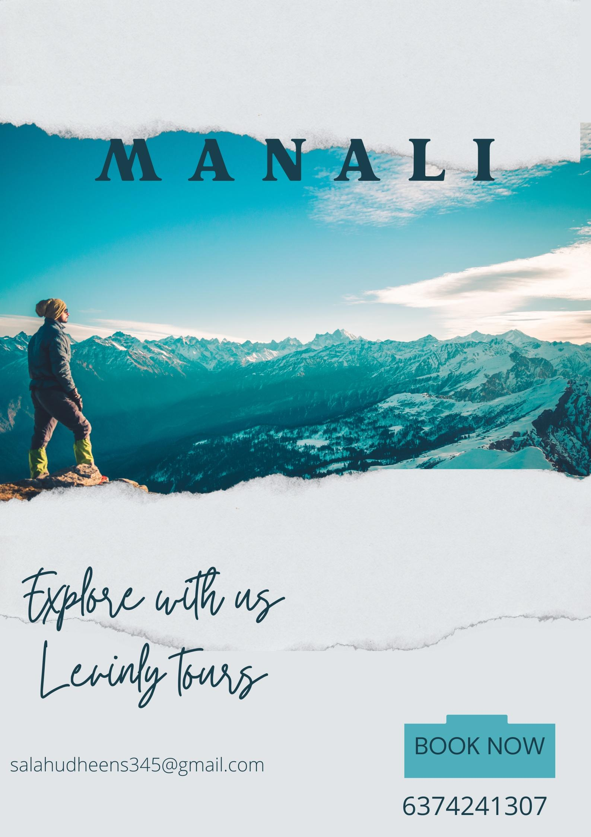

**2.Blog using blog spot**

[**https://levinlytravels.blogspot.com/2023/10/dream-away-fly-away.html**](https://levinlytravels.blogspot.com/2023/10/dream-away-fly-away.html)

In this blog using www.blogspot I had uploaded a blog with some information related to travelling along with certain photos of my venture. When a viewer read this blog, I am sure the viewer will definitely get interested in travelling with some tips to start a new venture.

**3.Email newsletter**

[**https://www.canva.com/design/DAFytgaXe80/1Em9XJvXXesqS4tQbd89IQ/edit?utm_content=DAFytgaXe80&utm_campaign=designshare&utm_medium=link2&utm_source=sharebutton**](https://www.canva.com/design/DAFytgaXe80/1Em9XJvXXesqS4tQbd89IQ/edit?utm_content=DAFytgaXe80&utm_campaign=designshare&utm_medium=link2&utm_source=sharebutton)

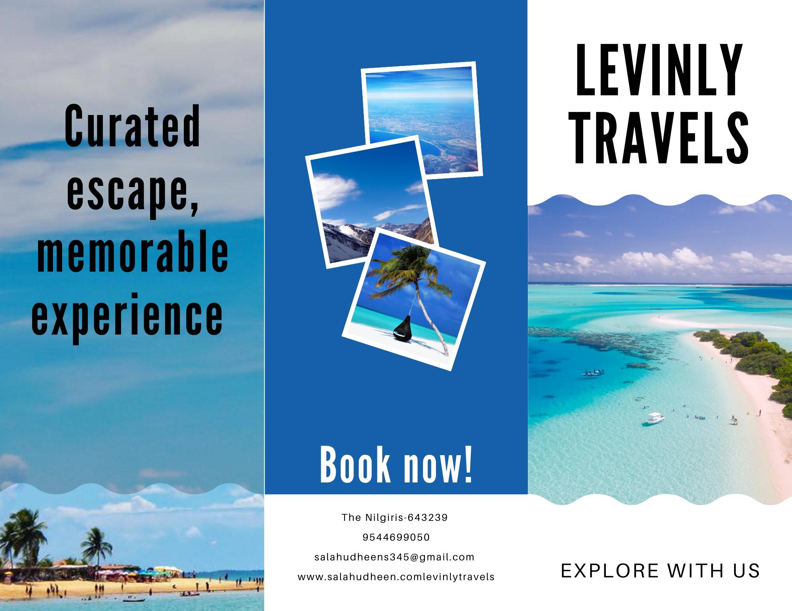

In this email newsletter I had uploaded 3 or 4 photos of my venture along with the personal contact informations regarding the venture.

**4.brand promoting post on face book page**

<https://m.facebook.com/story.php?story_fbid=pfbid02DfMZ3wKwPevd4aLaFP7G5HRbmPp1m4gC5Qm2pKd9mbUGKP8uMvZo4bkR8fCB6dZdl&id=61552849743288&mibextid=Nif5oz>

Through face book page formation I could gain various followers which results in wide audience who could promote my business.